From: https://andrewmtanner.medium.com/evaluating-putins-assault-on-ukraine-78f6bc0e0f18
Andrew Tanner
Andrew Tanner
Feb 25, 2022
A 6 min read, or you can just click 'Listen' and hear the page !
Listen

Evaluating Putin’s Assault On Ukraine

Russia is deliberately doing to Ukraine now what America did to Iraq in 2003 — Putin is sending a stark message to the world.
It is this: Russia is America’s equal, and NATO cannot deter Putin from re-writing the borders of Europe as he pleases.
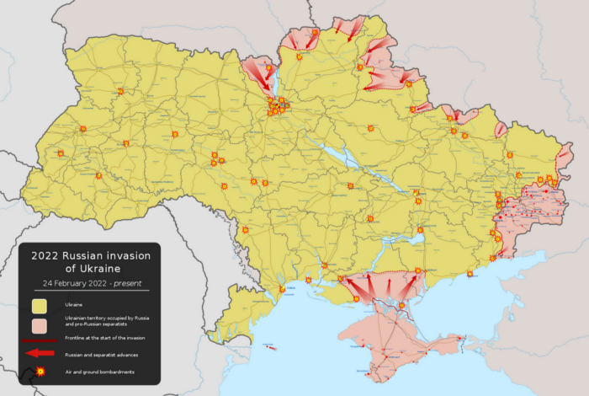
Russian invasion of Ukraine as of February 25, 2022. From Wiki Commons, by Viewsridge.
In the great game of global power politics, messaging is everything after hard power. True deterrence is the ability to stop your enemy from doing what they want, not imposing costs on their actions.
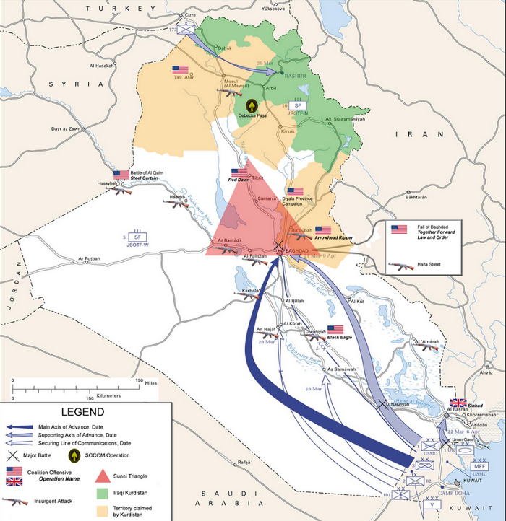
Invasion of Iraq in 2003 from Wiki Commons by ADuran. The US wanted more forces coming down from the north, but Turkey nixed the deployment.
Cowardly leaders of big countries like Putin and Biden lie constantly. To their public, to each other, and probably to themselves.
Biden’s predictable reliance on the stale idea of deterrence, mistakenly defined in American expert circles imposing costs for actions you don’t like, effectively sold Ukraine to Russia. He more or less proved over the past month that America won’t do anything to protect a so-called partner and ally.
I’ve been mostly correct in my assessment of Putin and his strategy so far. I didn’t expect the initial attack on Ukraine to be as widespread as it has proven, and did think the threat to attack Kyiv directly was primarily a feint designed to make it easier to destroy Ukraine’s fighting forces in the east of the country, near Donbas.
But Putin has decided to go maximalist, clearly perceiving that Ukraine’s government can be toppled if Kyiv is surrounded. Forces in Belarus I thought would hold off because a slow seizure of Ukraine would be less risky charged south straight away, and are [but are?] now fighting on the outskirts of Kyiv.
What is interesting — at least to a defense-minded person like myself — is that Putin’s initial air strikes were not as heavy as they could have been. As horrifying as they were, their primary functions were to:
- Eliminate Ukraine’s air force and long-range air defenses.
- Sow panic among Ukraine’s population and the rest of the world by showing Putin doesn’t care about optics as much as most analysts thought.
I was correct in predicting Putin’s aim was not simply taking territory, though. He’s after something more: replacing the Zelensky government so that Ukrainian military units start receiving conflicting orders from Kyiv.
Putin is now calling on Ukraine’s military to turn on the Zelensky government. Notably, the initial barrage of strikes did not appear designed to destroy all of Ukraine’s military infrastructure. Russia could have struck with thousands of missiles in the first volley — that’s how America likes to operate — but like America in 2003 appears to be holding off on hitting Ukrainian military units as hard as they could.
Instead it used around 160. These strikes took out radars and runways, giving Russia total air superiority.
Russia also launched a bold helicopter air assault on a major airbase right outside of Kyiv. Pictures of low-flying Russian transport choppers shooting off flares to stop any Stinger missile attacks came out early on, and most of day one there was apparently a big fight over the airfield Ukraine claimed to have won…
Right up until Russian armor moving south through Chernobyl — mostly seized to shock the world, I expect — linked up sometime during the night, Pacific time. A risky operation — stupidly risky, in truth. The fact Russia tried it shows how confident Putin is that NATO will not intervene.
Putin’s forces appear to have launched reconnaissance-in-force pushes all over the map. The reason it looks like many of the initial thrusts were blunted compared to those coming out of Crimea and Belarus is, I suspect, the fact that many were effectively feints again designed to keep Ukraine’s military guessing about where the main attack would fall.
So now Ukraine has to deal with forces on the outskirts of Kyiv, plus their major base in the south, Melitopol, has predictably been hit by forces coming from Crimea as well as Donbas, maybe even the sea too. Reports of naval landings near Odessa seem to have gotten mixed up with a simple air attack, possibly joined by commandos who pulled back soon after.
And, of course, there was the brave doomed stand on Snake island, where a squad of Ukrainian soldiers were wiped out by the Russian navy.
May the gods of Valhalla and Folkvangr receive you all, and may you dine for eternity with your bold ancestors!
Overall it appears that Putin’s aim is to take all of Ukraine but leave as much of its civilian and even military infrastructure intact. He really does want to swallow the whole country by putting a friendly puppet in charge in Kyiv.
And after that?
He wants to defeat NATO.
Truth be told, NATO has long outlived its purpose and is effectively a parasite on the collective body of Europe. None of this would be happening if NATO hadn’t expanded eastward after the Cold War.
Right or wrong, this gave Russian Christian nationalists like Putin and his cronies the excuse they needed to hold power, subjugating the proud Russian people to their malignant ideology. The same thing is happening in America with Trumpism too. These forces are fundamentally allied, and if not isolated and cut off from the world they will destroy it.
But now that Putin has proven he’s willing to use Russia’s armed forces to invade a free neighbor, whatever truth there may be to allegations of tolerating Nazis like the Azov battalion, the world is changed.
Every country bordering Russia has to be concerned about where this goes. Russia is not a stable place — Putin’s regime faces substantial domestic opposition and there can be little doubt someone would love to replace him when he someday dies.
Russia has no future but fragmentation and civil war — just like the United States of America. These twin imperial powers will die — and if the world isn’t careful, they will drag everyone down with them.
At this point, absent America doing something like deploying sufficient air and land power to actually defend Estonia, Latvia, and Lithuania from a sudden Russian attack, NATO is doomed. Article 5 is meaningless, because what America’s NATO allies don’t understand is just how bigoted even liberal Americans are when it comes to foreign policy.
If Putin launches a covert operation in Vilnius or Riga to overthrow the government, his nuclear arsenal will negate Article 5. Americans can never be trusted to risk New York to save the Baltics if Putin rattles his nuclear saber over them.
After all, that’s the reason Joe Biden has explicitly given for not defending a partner and ally. A nascent democracy is being crushed just as Afghanistan was because America’s leaders know they’ve been caught in a grand bluff.
From here, a lot is gonna unravel over the next few years. The 2020s will be, as I’ve long feared, a chaos decade that will reset everything.
It’s a brave new world, folks. Only those who can get hold of resources and apply them to build a working refuge are getting out of this somewhat unscathed.
The only hope any of us have is an alliance between the world’s true democracies.
The remnants of America that remain democratic after Trump’s assaults on the Constitution in 2024 and 2025 will be forced to forge a new global alliance to turn back the bigot tide.
Those countries willing to agree to a set of basic principles have to form their own United Nations, their own trade networks, and a new defense infrastructure that isn’t owned and controlled by corporate lobbyists for arms dealers.
In the end, this is the only way the world gets any better. The only chance we have of fighting the onset of climate collapse and the consequences of inequality, social, political, and economic.
Time has come to hive off whatever we can from the dying beasts that take our tax dollars and convert them to bombs instead of homes. To take back power from anyone who relies on their claim to authority as the sole basis of their rule.
It’s democracy, prosperity, and equality for all one way or another.

